Integrate Zscaler with Identity Providers (IdPs) such as Azure AD, Okta, and Active Directory for seamless authentication and authorization.

Integrate Zscaler with Identity Providers (IdPs) such as Azure AD, Okta, and Active Directory for seamless authentication and authorization.

List of Team Members:

S.No | Name | College Name | Contact
1. | Renuka.P | Sri Ramakrishna College of Arts and Science for Women | srcw2322k144@srcw.ac.in
2. | Shivani.A | Sri Ramakrishna College of Arts and Science for Women | srcw2322k150@srcw.ac.in
3. | Priyadharshini.k | Sri Ramakrishna College of Arts and Science for Women | srcw2322k140@srcw.ac.in
4. | Poovitha Sri.R | Sri Ramakrishna College of Arts and Science for Women | srcw2322k138@srcw.ac.in

Project Details

Title:
Integrate Zscaler with Identity Providers (IdPs) such as Azure AD, Okta, and Active Directory for seamless authentication and authorization.
Overview:
In today’s digital environment, organizations are rapidly adopting cloud technologies, remote work models, and distributed networks. Employees often need to access applications and data from various locations and devices. This creates new security challenges for organizations, as traditional network security methods such as Virtual Private Networks (VPNs) and perimeter-based security are no longer sufficient to protect sensitive resources. These traditional methods usually provide broad network access once a user is authenticated, which may increase the risk of unauthorized access and cyber threats.
To overcome these challenges, modern organizations are adopting the Zero Trust security model. The Zero Trust approach is based on the principle that no user or device should be trusted by default, even if they are inside the corporate network. Every access request must be verified before granting permission. This model ensures that only authenticated and authorized users can access specific applications and services.
This project focuses on integrating Zscaler with Identity Providers (IdPs) such as Azure Active Directory (Azure AD) to enhance secure user authentication and identity management. Identity Providers are responsible for managing user identities, authentication processes, and access permissions within an organization. By integrating Zscaler with Azure AD, organizations can implement secure authentication mechanisms that ensure only verified users are allowed to access corporate resources.
The integration enables features such as Single Sign-On (SSO), centralized identity management, and strong authentication policies. With Single Sign-On, users can access multiple applications using a single set of login credentials, which improves user convenience while maintaining high security standards. Administrators can also define access policies based on user roles, device conditions, and organizational security requirements.
In this project, Zscaler works as a secure cloud-based platform that verifies user identity through Azure AD before allowing access to applications. This approach ensures that users connect only to the applications they are authorized to use, without exposing the entire corporate network. As a result, the risk of cyber attacks, unauthorized access, and data breaches is significantly reduced.
The main objective of this project is to demonstrate how integrating Zscaler with Azure Active Directory improves identity-based security.
It ensures proper authentication and secure access control for users.
This approach helps organizations protect sensitive data using the Zero Trust security model
The main objective of this project is to demonstrate how integrating Zscaler with Azure Active Directory improves identity-based security and strengthens access control in enterprise environments. By connecting Zscaler with Azure AD, organizations can ensure that only authenticated and authorized users are allowed to access specific applications and resources. This integration helps to reduce security risks and provides better protection for sensitive organizational data.
In modern organizations, employees access applications from multiple locations such as offices, homes, and remote environments. This makes it important to verify the identity of users before granting access to any system or application. Identity Providers like Azure Active Directory play a major role in managing user identities, authentication processes, and access permissions. When integrated with Zscaler, Azure AD verifies the identity of users and ensures secure login before allowing them to access applications.
The integration also supports advanced authentication methods such as Single Sign-On (SSO). With SSO, users can log in once and access multiple applications without entering their credentials repeatedly. This improves user convenience while maintaining strong security controls. Administrators can also define security policies based on user roles, groups, and device conditions to ensure proper access management.
Another important advantage of integrating Zscaler with Azure AD is the implementation of the Zero Trust security model. In the Zero Trust approach, every access request is verified regardless of whether the user is inside or outside the organization’s network. This means that no user or device is trusted automatically, and access is granted only after proper authentication and authorization.
Through this project, the integration process between Zscaler and Azure Active Directory is demonstrated to show how organizations can strengthen their identity-based security infrastructure. This approach helps organizations protect sensitive data, prevent unauthorized access, and provide secure and efficient access to enterprise applications for authorized users.
integrating Zscaler with Azure Active Directory is improved monitoring, management, and control over user access. Administrators can easily track user login activities, authentication attempts, and access requests through a centralized identity management system. This helps organizations maintain better visibility of who is accessing the network and which resources are being used. In case of any unusual or suspicious activity, administrators can quickly detect and respond to potential security threats. Additionally, this integration allows organizations to enforce strong security policies such as multi-factor authentication, role-based access control, and conditional access. By implementing these security measures, organizations can reduce the chances of unauthorized access and data breaches. Overall, integrating Zscaler with Azure Active Directory helps organizations maintain a secure, reliable, and well-managed digital environment while ensuring safe and efficient access to applications and services for authorized users.

Use Case Scenarios:
Use Case Scenario 1: Secure User Authentication
An employee attempts to access a company application through Zscaler. The system integrates with Azure Active Directory to verify the user's identity before granting access.
Output:
- The user is authenticated through Azure AD credentials.
- Zscaler verifies the identity before allowing access.
- Unauthorized users are automatically blocked.
- A secure connection to the application is established.

Use Case Scenario 2: Single Sign-On (SSO) Access
A user logs in using Azure AD and wants to access multiple company applications without logging in repeatedly.
Output:
- The user signs in once using Azure AD credentials.
- Single Sign-On allows access to multiple authorized applications.
- User authentication is managed centrally.
- Security policies ensure safe and controlled access.

Use Case Scenario 3: Role-Based Access Control
Different employees such as managers, developers, and HR staff require access to different applications within the organization.
Output:
- Access permissions are assigned based on user roles.
- Employees can only access applications relevant to their role.
- Unauthorized application access is blocked automatically.
- Security policies enforce least-privilege access.

Use Case Scenario 4: Secure Access from Remote Locations
An employee working remotely tries to access internal company applications using the internet.
Output:
- The user identity is verified through Azure AD authentication.
- Zscaler provides a secure cloud-based connection.
- Internal applications remain hidden from the public internet.
- All access activities are monitored and logged.

Use Case Scenario 5: Multi-Factor Authentication Security
To improve security, the organization enables Multi-Factor Authentication (MFA) for application access.
Output:
- The user enters Azure AD login credentials.
- An additional verification step (OTP or mobile authentication) is required.
- Only verified users are granted application access.
- Security risks such as unauthorized logins are reduced.

Stage-1
Title:
Integrate Zscaler with Identity Providers (IdPs) such as Azure AD, Okta, and Active Directory for seamless authentication and authorization.
Overview:
In today’s digital environment, organizations are rapidly adopting cloud technologies, remote work models, and distributed networks. Employees often need to access applications and data from various locations and devices. This creates new security challenges for organizations, as traditional network security methods such as Virtual Private Networks (VPNs) and perimeter-based security are no longer sufficient to protect sensitive resources. These traditional methods usually provide broad network access once a user is authenticated, which may increase the risk of unauthorized access and cyber threats.
To overcome these challenges, modern organizations are adopting the Zero Trust security model. The Zero Trust approach is based on the principle that no user or device should be trusted by default, even if they are inside the corporate network. Every access request must be verified before granting permission. This model ensures that only authenticated and authorized users can access specific applications and services.
This project focuses on integrating Zscaler with Identity Providers (IdPs) such as Azure Active Directory (Azure AD) to enhance secure user authentication and identity management. Identity Providers are responsible for managing user identities, authentication processes, and access permissions within an organization. By integrating Zscaler with Azure AD, organizations can implement secure authentication mechanisms that ensure only verified users are allowed to access corporate resources.
The integration enables features such as Single Sign-On (SSO), centralized identity management, and strong authentication policies. With Single Sign-On, users can access multiple applications using a single set of login credentials, which improves user convenience while maintaining high security standards. Administrators can also define access policies based on user roles, device conditions, and organizational security requirements.
In this project, Zscaler works as a secure cloud-based platform that verifies user identity through Azure AD before allowing access to applications. This approach ensures that users connect only to the applications they are authorized to use, without exposing the entire corporate network. As a result, the risk of cyber attacks, unauthorized access, and data breaches is significantly reduced.
The main objective of this project is to demonstrate how integrating Zscaler with Azure Active Directory improves identity-based security.
It ensures proper authentication and secure access control for users.
This approach helps organizations protect sensitive data using the Zero Trust security model

List of Team Members:

S.No | Name | College Name | Contact
1. | Renuka.P | Sri Ramakrishna College of Arts and Science for Women | srcw2322k144@srcw.ac.in
2. | Shivani.A | Sri Ramakrishna College of Arts and Science for Women | srcw2322k150@srcw.ac.in
3. | Priyadharshini.k | Sri Ramakrishna College of Arts and Science for Women | srcw2322k140@srcw.ac.in
4. | Poovitha Sri.R | Sri Ramakrishna College of Arts and Science for Women | srcw2322k138@srcw.ac.in

List Of Vulnerability Name:

S.No. | Category Name | Vulnerability Name | CWE - No
1 | Broken Access Control | Incorrect Default permissions | CWE-276
2 | Security Misconfiguration | Use of Hard-coded, Security-relevant Constants | CWE-547
3 | Software Supply Chain Failures | Reliance on Component That is Not Updateable | CWE-1329
4 | Cryptographic Failures | Inadequate Encryption Strength | CWE-326
5 | Injection | Improper Neutralization of Argument Delimiters in a Command ('Argument Injection') | CWE-88
6 | Insecure Design | Cleartext Storage of Sensitive Information in Memory | CWE-316
7 | Authentication Failures | Improper Certificate Validation | CWE-295
8 | Software or Data Integrity Failures | Reliance on Cookies without Validation and Integrity Checking in a Security Decision | CWE-784
9 | Security Logging and Alerting Failures | Insufficient Logging | CWE-778
10 | Mishandling of Exceptional Conditions | Detection of Error Condition Without Action | CWE-390

REPORT
1 .Vulnerability Name: Incorrect Default permissions
CWE/CVE: CWE-276
OWASP Category: A01:2025 Broken Access Control
Description: Incorrect Default Permissions occur when applications, files, or system resources are configured with overly permissive access rights by default. This means that users or systems may have more privileges than necessary to perform their tasks. If proper access controls are not implemented, unauthorized users may gain access to sensitive data, modify system settings, or perform actions that should normally be restricted. In many cases, default configurations provided by systems or applications are not changed by administrators, which can create potential security risks.

Business Impact: Incorrect Default Permissions can expose sensitive data and critical system resources to unauthorized users. Attackers may exploit these permissions to read confidential information, modify files, or disrupt normal system operations. This can lead to data breaches, loss of important business information, and damage to the organization’s reputation. Additionally, it may result in compliance issues and financial losses if sensitive customer or company data is compromised. Proper configuration and strict access control policies are necessary to prevent such risks.

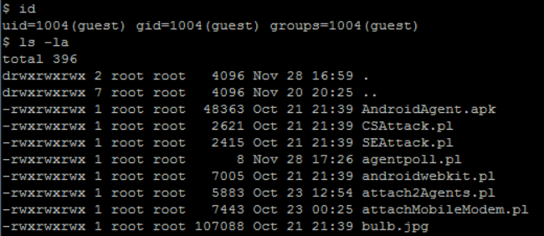
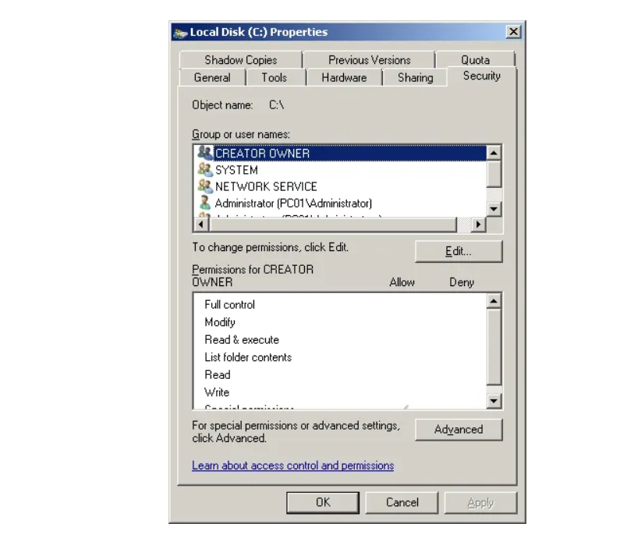
Recommendation:
- Apply the Principle of Least Privilege: Grant users and applications only the minimum permissions required to perform their tasks.
- Review Default Configurations: Modify default permission settings during installation to ensure secure access control.
- Implement Role-Based Access Control (RBAC): Assign permissions based on user roles rather than individual users.
- Regular Security Audits:Periodically review file permissions, directory permissions, and access control policies.
- Use Identity-Based Access Management:Integrate systems with identity providers such as Azure Active Directory to manage authentication and authorization centrally.

2. Vulnerability Name: Use of Hard-coded, Security-relevant Constants
CWE/CVE: CWE-547
OWASP Category: A02:2025 Security Misconfiguration
Description: Use of Hard-coded Security-relevant Constants is a vulnerability that occurs when sensitive information such as passwords, encryption keys, API keys, or authentication tokens are directly written into the source code of an application. These values remain fixed in the program and cannot be changed easily without modifying the code. If attackers gain access to the source code through reverse engineering, repositories, or system access, they may discover these hard-coded credentials and use them to bypass authentication or gain unauthorized access to systems and data. This practice weakens application security because sensitive information should be stored securely and managed through configuration files or secure key management systems rather than being embedded directly in the code.

Business Impact: The use of hard-coded security constants can create serious security risks for an organization. If attackers discover these embedded credentials, they may gain unauthorized access to applications, databases, or external services. This can lead to data breaches, exposure of confidential information, and compromise of critical systems. Attackers may also misuse these credentials to perform malicious actions such as modifying data, disrupting services, or accessing restricted resources. Such incidents can cause financial losses, damage the organization’s reputation, and lead to non-compliance with security standards and regulations.
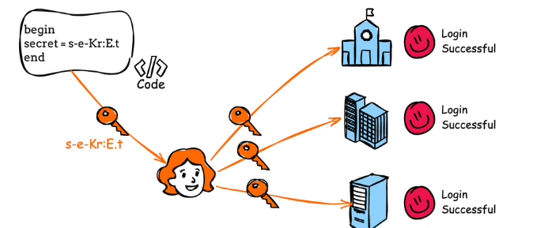

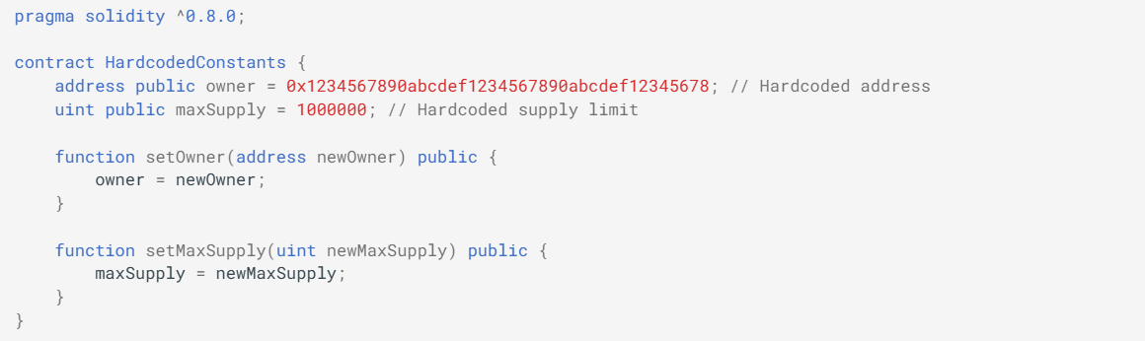

Recommendation:
- Avoid Hard-coding Sensitive Information: Do not store passwords, API keys, or encryption keys directly in the source code.
- Use Secure Configuration Files: Store sensitive data in protected configuration files or environment variables instead of embedding them in code.
- Implement Secret Management Tools: Use secure secret management systems such as vault services to manage credentials safely.
- Apply Access Control Policies: Restrict access to sensitive configuration files and credentials.
- Rotate Credentials Regularly: Periodically update passwords, API keys, and tokens to reduce the risk of compromise.

3. Vulnerability Name: Reliance on Component That is Not Updateable
CWE/CVE: CWE-1329
OWASP Category: A03:2025 Software Supply Chain Failures
Description: Reliance on Component That is Not Updateable is a vulnerability that occurs when an application or system depends on a software component, library, or module that cannot be updated or patched easily. These components may be outdated, unsupported, or embedded in a way that prevents security updates from being applied. If vulnerabilities are discovered in such components, developers or administrators may not be able to fix them quickly. As a result, attackers can exploit known security weaknesses in these outdated components to compromise the system, gain unauthorized access, or disrupt services.

Business Impact: Using components that cannot be updated can expose organizations to long-term security risks. If a vulnerability is discovered in the component, attackers may exploit it to access sensitive information or damage system functionality. This can lead to data breaches, service disruptions, and compromise of critical business operations. Additionally, organizations may face financial losses, reputational damage, and compliance issues if they continue using unsupported or outdated components that cannot be patched or secured properly.

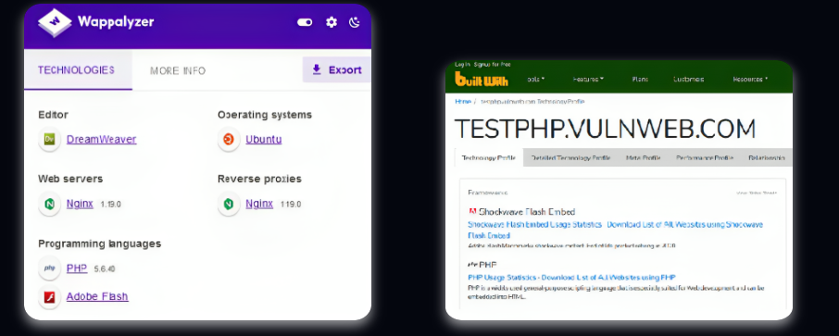

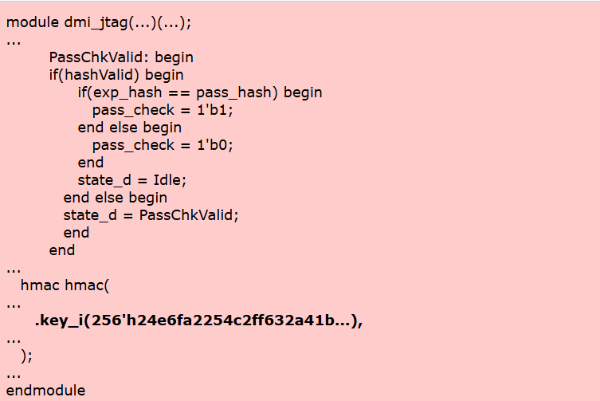

Recommendation:
- Use Actively Maintained Components: Select software libraries and components that are regularly updated and supported by developers.
- Monitor Component Updates: Regularly check for updates, security patches, and vulnerability advisories for all third-party components.
- Replace Unsupported Components: Avoid using outdated or deprecated libraries and replace them with secure and supported alternatives.
- Implement Dependency Management Tools: Use tools that automatically track and manage third-party dependencies and their security status.
- Perform Regular Security Audits: Conduct periodic reviews to identify outdated or vulnerable components used in the system.

4. Vulnerability Name: Inadequate Encryption Strength

CWE/CVE : CWE-326

OWASP Category: A04:2025 Cryptographic Failures
Description: Inadequate Encryption Strength is a vulnerability that occurs when weak or outdated encryption algorithms are used to protect sensitive data. This may happen when applications use old cryptographic standards, short encryption keys, or insecure protocols that do not provide strong protection. Because of weak encryption, attackers may be able to break the encryption using modern tools and techniques, allowing them to read or manipulate confidential information such as passwords, personal data, or financial records. Proper encryption strength is important to ensure that sensitive information remains secure during storage and transmission.

Business Impact: Inadequate encryption strength can expose an organization’s sensitive data to attackers who may be able to decrypt protected information. If encryption is weak, cybercriminals may intercept and decode confidential data during transmission or gain access to stored information. This can lead to data breaches, financial loss, identity theft, and misuse of sensitive business information. Such incidents may also damage the organization’s reputation, reduce customer trust, and result in legal or regulatory penalties for failing to protect sensitive data properly.
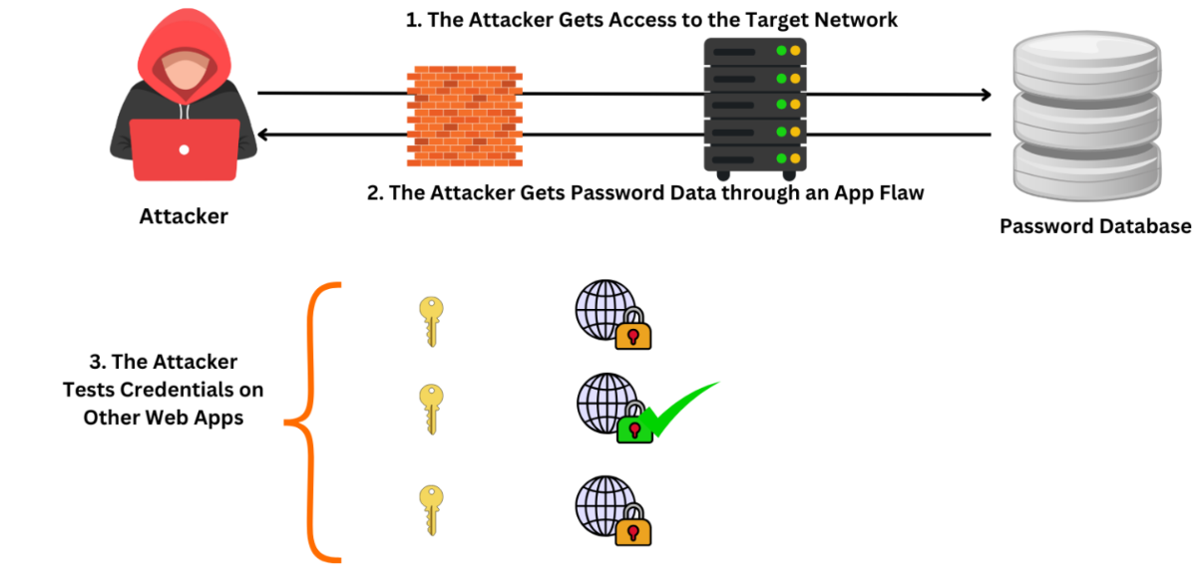

Recommendation:
- Use Strong Encryption Algorithms: Implement strong cryptographic algorithms such as AES-256 for protecting sensitive data.
- Use Secure Protocols: Ensure that secure protocols like TLS 1.2 or TLS 1.3 are used instead of outdated protocols such as SSL.
- Increase Key Length: Use sufficiently long encryption keys to make it difficult for attackers to break the encryption.
- Disable Weak Cipher Suites: Remove weak or deprecated encryption algorithms from the system configuration.
- Update Cryptographic Libraries: Regularly update encryption libraries and frameworks to maintain strong security standards.

5. Vulnerability Name: Improper Neutralization of Argument Delimiters in a Command ('Argument Injection')

CWE/CVE : CWE-88

OWASP Category: A05:2025 Injection
Description: Improper Neutralization of Argument Delimiters in a Command, commonly known as Argument Injection, occurs when an application fails to properly validate or sanitize user input that is passed to system commands. In such cases, attackers can manipulate command arguments by inserting special characters or additional parameters that change the behavior of the command being executed. This vulnerability usually appears when applications directly include user input in command-line instructions without proper filtering. As a result, attackers may be able to execute unintended commands, access restricted system information, or modify system operations.

Business Impact: Argument Injection can create serious security risks for organizations because attackers may exploit the vulnerability to execute unauthorized commands on the server or system. This can allow them to access sensitive data, modify system files, or disrupt application functionality. In severe cases, attackers may gain control over the system or escalate their privileges, leading to data breaches or service disruptions. Such incidents can impact business operations, cause financial losses, and damage the organization’s reputation if critical systems are compromised.
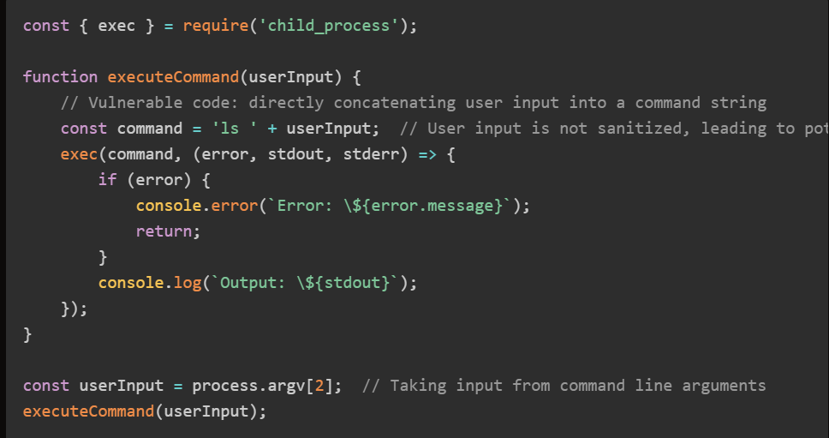
Recommendation:
- Validate and Sanitize User Input: Ensure all user inputs are properly validated and filtered before being used in system commands.
- Avoid Direct Command Execution: Do not directly pass user input to system commands; use secure APIs or built-in functions instead.
- Use Parameterized Commands: Implement parameterized methods that safely handle command arguments.
- Apply Principle of Least Privilege: Run applications with minimal system privileges to limit potential damage if an attack occurs.
- Perform Security Testing: Conduct regular code reviews and vulnerability scanning to detect command injection issues.

6. Vulnerability Name: Cleartext Storage of Sensitive Information in Memory
CWE/CVE : CWE-316

OWASP Category: A06:2025 Insecure Design

Description: Cleartext Storage of Sensitive Information in Memory is a vulnerability that occurs when sensitive data such as passwords, encryption keys, authentication tokens, or personal information is stored in system memory without encryption or protection. When this information is stored in plain text, it can potentially be accessed by attackers through memory dumps, debugging tools, or malware. Since the data is not encrypted or properly secured in memory, attackers who gain access to the system may be able to retrieve and misuse this sensitive information.
Business Impact: Cleartext storage of sensitive information in memory can expose critical data to attackers if they gain access to the system or application memory. Sensitive details such as user credentials, financial information, or authentication tokens may be stolen and used for unauthorized access or identity theft. This can lead to data breaches, financial loss, and compromise of user accounts. Additionally, organizations may face reputational damage and regulatory penalties if sensitive data is not properly protected according to security standards and data protection regulations.

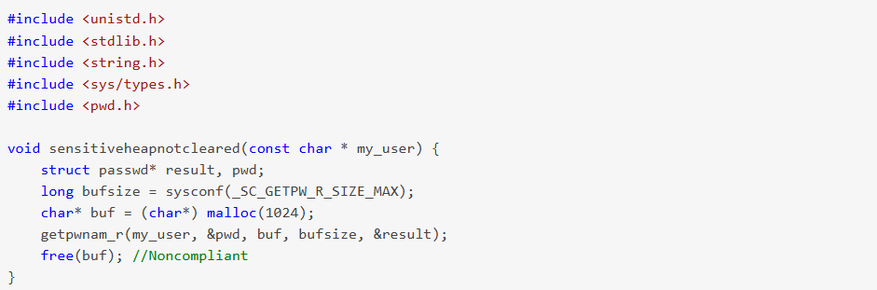
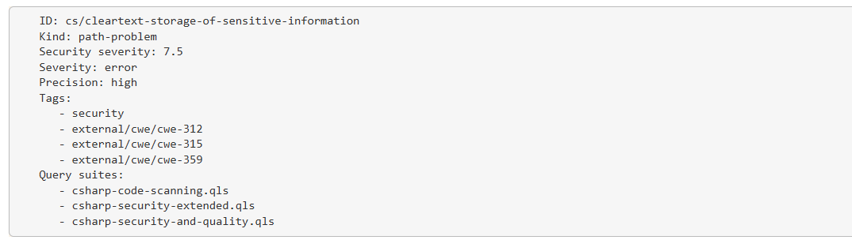
Recommendation:
- Avoid Storing Sensitive Data in Plain Text: Sensitive information should not be stored in memory in cleartext format.
- Use Encryption for Sensitive Data: Encrypt sensitive information before storing or processing it in memory.
- Clear Sensitive Data from Memory: Ensure that sensitive data is removed or overwritten from memory immediately after it is no longer needed.
- Use Secure Memory Handling Techniques: Implement secure programming practices that protect sensitive data in memory.
- Restrict Access to Memory Dumps: Limit system access and prevent unauthorized users from retrieving memory dumps.

7. Vulnerability Name: Improper Certificate Validation

CWE/CVE : CWE-295

OWASP Category: A07:2025 Authentication Failures
Description: Improper Certificate Validation occurs when an application fails to properly verify the authenticity and validity of a digital certificate during secure communication. Digital certificates are used to establish trust between a client and a server when using secure protocols such as HTTPS. If an application does not correctly validate the certificate—such as checking the certificate authority, expiration date, or domain name—attackers may exploit this weakness by presenting a fake or malicious certificate. This can allow attackers to intercept and manipulate communication between the client and server through attacks like man-in-the-middle (MITM).

Business Impact: Improper Certificate Validation can expose sensitive communication to attackers who may intercept and modify data exchanged between users and servers. This can lead to the disclosure of confidential information such as login credentials, personal data, or financial details. Attackers may also impersonate legitimate servers and trick users into connecting to malicious systems. Such incidents can result in data breaches, financial losses, and loss of customer trust. Additionally, organizations may face reputational damage and regulatory penalties if secure communication is not properly protected.

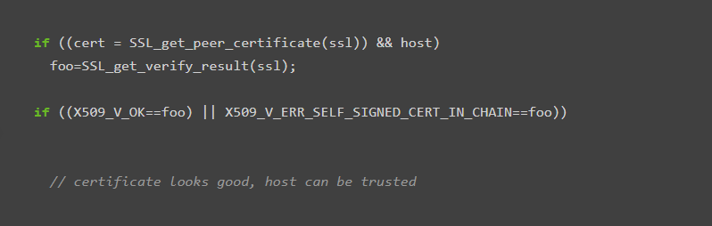
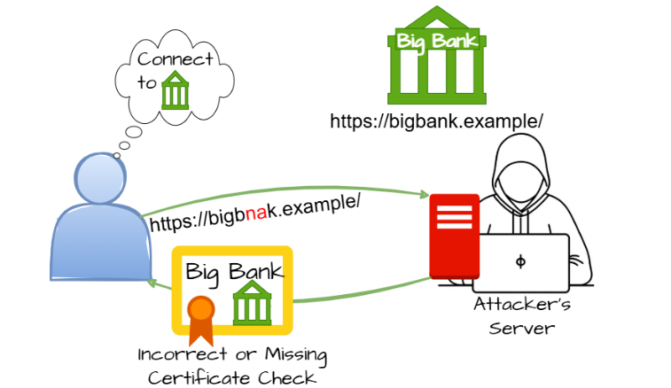
Recommendation:
- Implement Proper Certificate Validation: Ensure that applications verify the authenticity of certificates issued by trusted certificate authorities.
- Check Certificate Expiry and Domain Name: Validate the certificate’s expiration date and confirm that the domain name matches the intended server.
- Use Trusted Certificate Authorities: Accept certificates only from trusted and verified certificate authorities.
- Enable Secure Communication Protocols: Use secure protocols such as HTTPS with TLS for all sensitive communications.
- Avoid Disabling Certificate Verification: Do not bypass or disable certificate validation in application code.

8. Vulnerability Name: Reliance on Cookies without Validation and Integrity Checking in a Security Decision

CWE/CVE : CWE-784

OWASP Category: A08:2025 Software or Data Integrity Failures
Description: Reliance on Cookies without Validation and Integrity Checking occurs when an application uses cookies to make important security decisions without properly verifying their authenticity or integrity. Cookies are often used to store session IDs, user roles, or authentication information. If the application does not validate these cookies or protect them from modification, attackers may manipulate the cookie values to gain unauthorized privileges or bypass authentication mechanisms. Since cookies are stored on the client side, they can be easily modified if proper validation and protection mechanisms are not implemented.
Business Impact: This vulnerability can allow attackers to manipulate cookie values and gain unauthorized access to restricted areas of an application. For example, attackers may change a cookie value to escalate their privileges or impersonate another user. This can lead to unauthorized access to sensitive data, modification of user accounts, and potential compromise of the application. As a result, organizations may experience data breaches, loss of customer trust, financial losses, and reputational damage if attackers exploit cookie-based security weaknesses.
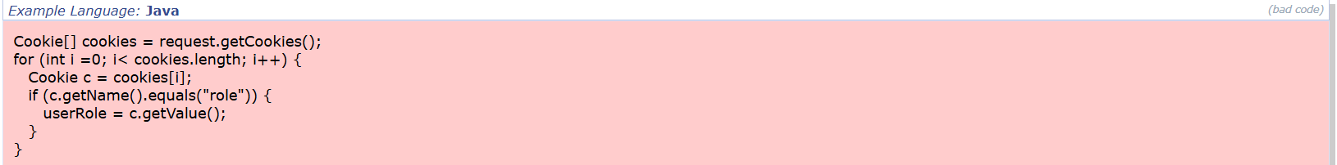

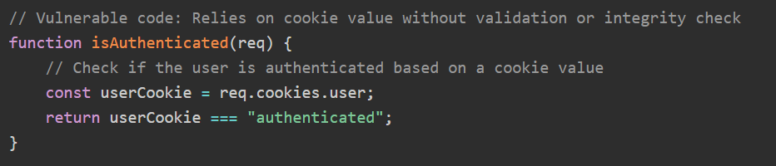

Recommendation:

- Validate Cookie Values: Always verify cookie data on the server side before using it for authentication or authorization decisions.
- Use Secure Session Management: Store sensitive session information on the server instead of relying only on client-side cookies.
- Implement Cookie Integrity Protection: Use cryptographic techniques such as signing or encryption to prevent cookie tampering.
- Set Secure Cookie Attributes: Configure cookies with security flags such as Secure, HttpOnly, and SameSite.
- Avoid Storing Sensitive Data in Cookies: Do not store confidential information such as passwords or user roles directly in cookies.

9. Vulnerability Name: Insufficient Logging

CWE/CVE : CWE-778

OWASP Category: A09:2025 Security Logging & Alerting Failures
Description: Insufficient Logging is a vulnerability that occurs when an application or system does not properly record important events such as user activities, login attempts, system errors, or security-related actions. Logging is important for monitoring system behavior and detecting suspicious activities. If logging mechanisms are weak or incomplete, security incidents may go unnoticed and administrators may not have enough information to investigate or respond to attacks. Without proper logging, it becomes difficult to track unauthorized access, detect malicious actions, or identify the source of security breaches.

Business Impact: Insufficient Logging can significantly affect an organization’s ability to detect and respond to security incidents. If important system activities are not properly recorded, attackers may perform malicious actions without being detected. This can lead to unauthorized access, data breaches, and system compromise without leaving clear evidence for investigation. As a result, organizations may face operational disruptions, financial losses, and reputational damage. Additionally, the lack of proper logs may also result in non-compliance with security standards and regulatory requirements that require monitoring and auditing of system activities.

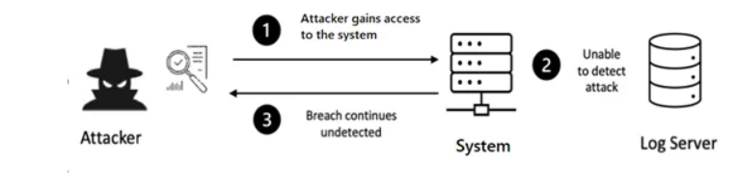
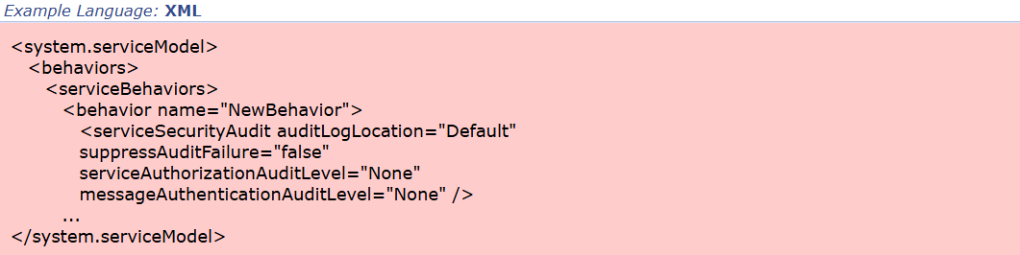

Recommendation:
- Implement Comprehensive Logging: Ensure that all important system activities such as login attempts, file access, and configuration changes are properly logged.
- Monitor Logs Regularly: Regularly review system logs to detect unusual or suspicious activities.
- Protect Log Files: Store log files securely and restrict access to authorized personnel only.
- Enable Real-time Monitoring: Use monitoring tools or security systems to analyze logs and detect threats in real time.
- Maintain Log Retention Policies: Keep logs for an appropriate period to support security investigations and compliance requirements.

10. Vulnerability Name: Detection of Error Condition Without Action

CWE/CVE : CWE-390

OWASP Category: A10:2025 Mishandling of Exceptional Conditions
Description: Detection of Error Condition Without Action is a vulnerability that occurs when an application detects an error or exceptional condition but fails to take appropriate action to handle or mitigate the problem. In such cases, the system may recognize that something has gone wrong, but it does not properly log the issue, notify administrators, or stop the execution of unsafe operations. As a result, the application may continue running in an unstable or insecure state. This can lead to unexpected behavior, security weaknesses, or system failures if the error condition is exploited or left unresolved.
Business Impact: When an application detects an error but does not respond appropriately, it can create opportunities for attackers to exploit system weaknesses. The system may continue to operate with incorrect data or insecure conditions, which can lead to data corruption, unauthorized access, or disruption of services. Additionally, the lack of proper response to errors makes it difficult for administrators to identify and fix issues quickly. This can affect business operations, reduce system reliability, and potentially lead to financial losses or reputational damage if critical services are impacted.

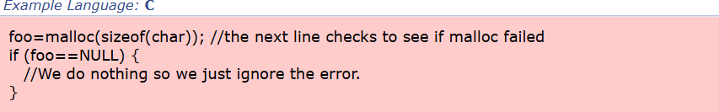

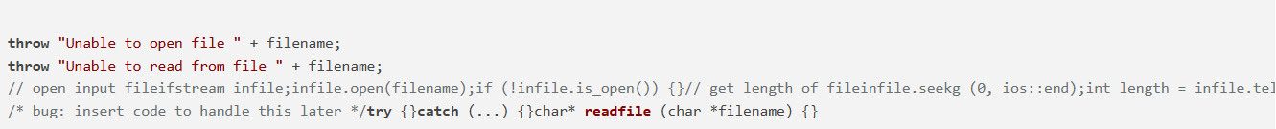
Recommendation:
- Implement Proper Error Handling: Ensure that all detected errors are handled appropriately through corrective actions or safe termination of processes.
- Log Error Events: Record all error conditions in system logs to help administrators identify and investigate issues.
- Notify Administrators: Implement alert mechanisms to notify administrators when critical errors occur.
- Stop Unsafe Operations: Prevent the system from continuing operations that may cause further security risks or data corruption.
- Perform Regular Testing: Conduct testing and code reviews to ensure that all error conditions are properly handled.

Stage 2

Overview:
Nessus is a powerful and widely used vulnerability assessment tool developed by Tenable to help organizations identify security weaknesses in their networks, systems, and applications. It is commonly used by cybersecurity professionals, system administrators, and security analysts to perform vulnerability scanning and ensure that IT infrastructure remains protected from potential threats. Nessus works by scanning systems and comparing the detected configurations, software versions, and services with a large and continuously updated database of known vulnerabilities.
The primary purpose of Nessus is to detect vulnerabilities before attackers can exploit them. It can identify a wide range of security issues, including outdated software, missing security patches, misconfigured systems, weak passwords, and open network ports. By detecting these vulnerabilities early, organizations can take preventive actions to fix security gaps and strengthen their overall security posture.
Nessus operates by sending requests to the target system and analyzing the responses to determine whether vulnerabilities exist. During the scanning process, the tool checks various components such as operating systems, network devices, databases, and web applications. It performs thousands of vulnerability checks using plugins, which are small programs designed to test specific security weaknesses. These plugins are frequently updated by Tenable to ensure that Nessus can detect newly discovered vulnerabilities.
One of the key strengths of Nessus is its ability to provide detailed vulnerability reports. After completing a scan, Nessus generates a comprehensive report that categorizes vulnerabilities based on their severity levels, such as Critical, High, Medium, Low, and Informational. These reports include descriptions of the vulnerabilities, the affected systems, potential risks, and recommendations for remediation. This helps security teams prioritize which vulnerabilities should be addressed first.
Another important feature of Nessus is its flexibility and wide range of scanning capabilities. It supports different types of scans, including network scanning, host discovery, compliance checks, malware detection, and configuration auditing. Nessus can perform both authenticated and unauthenticated scans. Authenticated scans allow deeper analysis by logging into the target system with authorized credentials, while unauthenticated scans analyze systems from an external perspective, similar to how an attacker might attempt to discover vulnerabilities.
In addition, Nessus integrates with other security solutions and platforms to enhance security management. It can work alongside various security monitoring systems and vulnerability management tools to provide continuous monitoring and risk assessment. Because of its reliability, accuracy, and comprehensive vulnerability detection capabilities, Nessus has become one of the most trusted vulnerability scanning tools used by organizations worldwide.
Overall, Nessus plays a crucial role in modern cybersecurity practices by helping organizations proactively identify and remediate security weaknesses, thereby reducing the risk of cyberattacks and improving the overall security of their systems and networks.
Step-by-Step Explanation of How Nessus Works
- Installation and Setup: First, Nessus is downloaded and installed on a system. After installation, the user activates the tool using a license or activation code and completes the initial configuration.
- Creating a Scan: The user creates a new scan by selecting the type of scan (such as basic network scan or web application scan) and entering the target IP address, domain name, or network range that needs to be analyzed.
- Configuration of Scan Settings: Before starting the scan, the user can configure scanning options such as authentication details, port scanning settings, and vulnerability checks to ensure accurate results.
- Vulnerability Scanning: Nessus begins scanning the target system by checking open ports, running services, installed software, and system configurations. It compares these findings with its vulnerability database to detect known security issues.
- Analysis of Results: After completing the scan, Nessus analyzes the collected data and identifies vulnerabilities based on severity levels such as Critical, High, Medium, Low, and Informational.
- Report Generation: Finally, Nessus generates a detailed report that lists the vulnerabilities detected, their severity level, affected components, and recommendations for fixing them.

Benefits of Using Nessus
- Accurate Vulnerability Detection: Nessus provides highly accurate vulnerability detection using an extensive and regularly updated vulnerability database.
- Easy to Use: The tool has a user-friendly interface that makes it easy for both beginners and security professionals to perform vulnerability assessments.
- Detailed Reports: Nessus generates detailed vulnerability reports with descriptions, risk levels, and remediation suggestions.
- Regular Updates: The vulnerability database is frequently updated to detect the latest security threats and vulnerabilities.
- Wide Range of Security Checks: Nessus can detect various security issues such as missing patches, configuration errors, malware risks, and outdated software.
- Helps Improve Security: By identifying vulnerabilities early, organizations can fix security issues before attackers exploit them.

List of vulnerability:-
S.No | Vulnerability name | Severity | Plugins
1. | HTTP Server Type and Version | Info | 10107
2. | HyperText Transfer Protocol (HTTP) Information | Info | 24260
3. | Service Detection | Info | 22964
4. | Apache Tomcat Detection | Info | 39446
5. | Nessus SYN scanner | Info | 11219
6. | Common Platform Enumeration (CPE) | Info | 45590
7. | Device Type | Info | 54615
8. | Nessus Scan Information | Info | 19506
9. | InfoOpen Port Re-check | Info | 10919
10. | OS Fingerprints Detected | Info | 209654
11. | OS Identification | Info | 11936
12. | Traceroute Information | Info | 10287

Report:
1.Vulnerability Name: 10107 - HTTP Server Type and Version
Severity: Info
Plugin: 10107
Port: 443
Description: The scan has detected the type and version of the HTTP server running on the target system. Web servers such as Apache HTTP Server, Nginx, or Microsoft IIS often include their version information in HTTP response headers. This information is usually visible in headers like Server: when a request is sent to the web server.
When server type and version details are exposed, attackers can use this information to identify known vulnerabilities associated with that specific server version. Public vulnerability databases such as CVE repositories often list security flaws affecting specific versions of web servers. By gathering this information during reconnaissance, attackers can plan targeted attacks that exploit known weaknesses in the server software.
Solution: Configure the web server to hide or mask its version information in HTTP response headers. This can be done by modifying server configuration settings to remove or obfuscate server details from public responses.
Business Impact: Exposing HTTP server type and version information increases the risk of targeted attacks. Attackers may leverage this information to identify known vulnerabilities and develop exploits specific to that server version. If successful, this could result in unauthorized system access, service disruption, or data breaches. Organizations may experience operational downtime, loss of customer trust, and reputational damage if attackers exploit outdated or vulnerable server software.

2. Vulnerability Name: 24260 - HyperText Transfer Protocol (HTTP) Information
Severity: Info
Plugin: 24260
Port: 80
Description: This finding indicates that general HTTP information has been gathered from the target server. This may include supported HTTP methods, response headers, cookies, and other configuration details returned during HTTP requests. The information helps identify how the web server communicates and processes requests.
The data collected may reveal configuration details such as supported HTTP methods (GET, POST, PUT, DELETE, etc.), caching mechanisms, redirection behavior, and session management. Attackers can use this information to better understand the server environment and identify potential misconfigurations or weaknesses that could be exploited.
Solution: Ensure that the HTTP service is properly configured and secured. Disable unnecessary HTTP methods, implement HTTPS for secure communication, and apply security headers to protect the web application.
Business Impact: While this information alone does not directly compromise the system, it provides attackers with useful details about how the server communicates. Attackers may analyze this information to identify weak configurations, outdated protocols, or potential vulnerabilities in the web server. If misconfigured services exist, it may lead to further exploitation or unauthorized access.

3. Vulnerability Name: 22964 - Service Detection
Severity: Info
Plugin: 22964
Port: 80
Description: Service detection identifies the services running on open ports of a system and determines the associated software and versions. During scanning, the vulnerability scanner sends probes to open ports to determine which services are active.
Examples of services that may be detected include web servers, database services, file transfer services, or remote access services. Identifying these services helps security teams understand the attack surface of the system.
However, attackers can also use service detection to map the system architecture and determine which services may contain vulnerabilities.
Solution: Review all detected services and ensure that only necessary services are running. Disable or restrict access to unused services and implement firewall rules to limit exposure.
Business Impact: If service information is publicly accessible, attackers can identify potential entry points into the system. Vulnerable or outdated services may be targeted using known exploits. This could lead to unauthorized access, service disruptions, or compromise of sensitive systems within the network.

4.Vulnerability Name: 39446 - Apache Tomcat Detection
Severity: Info
Plugin: 39446
Port: 80
Description: The scan has detected the presence of the Apache Tomcat application server on the target host. Apache Tomcat is a widely used open-source server used to deploy Java-based web applications.
Detection typically occurs through banner information, HTTP responses, or default application paths. If Tomcat is improperly configured or running outdated versions, it may contain vulnerabilities such as default credentials, exposed management interfaces, or remote code execution flaws.

Solution: Ensure that the Apache Tomcat server is updated to the latest secure version. Disable unnecessary default applications and configure strong authentication and access controls.
Business Impact: If attackers identify an Apache Tomcat server running vulnerable versions or misconfigured services, they may exploit known vulnerabilities to gain unauthorized access or execute malicious code on the server. This could result in system compromise, unauthorized data access, application downtime, and potential damage to organizational operations.

5.Vulnerability Name: 11219 - Nessus SYN Scanner
Severity: Info
Plugin: 11219
Port: 80
Description: The Nessus SYN scanner performs a TCP SYN scan to identify open ports on a target system. This type of scan sends a SYN packet to initiate a TCP connection but does not complete the full handshake. If the target responds with a SYN-ACK packet, the port is considered open.
This scanning technique is commonly used for network reconnaissance because it is faster and less intrusive than full connection scans. It helps identify accessible services and potential attack vectors.
Solution: Implement firewall rules or intrusion detection systems to monitor and control unauthorized scanning activities. Restrict unnecessary open ports and limit network exposure.
Business Impact: Although SYN scanning itself is not a vulnerability, it reveals open ports that could expose critical services. Attackers can use this information to identify accessible services and attempt exploitation. If sensitive services are exposed unnecessarily, this could increase the risk of system compromise or unauthorized access.

6.Vulnerability Name: 45590 - Common Platform Enumeration (CPE)
Severity: Info
Plugin: 45590
Port: N/A
Description: Common Platform Enumeration (CPE) is a standardized naming scheme used to identify software, hardware, and operating systems. During scanning, Nessus may associate detected systems or services with CPE identifiers that match known products.
These identifiers allow vulnerability scanners to compare detected systems with known vulnerabilities listed in security databases.
Solution: Ensure that identified platforms and software components are regularly updated and patched. Monitor vulnerability databases that reference CPE identifiers to stay informed about potential security issues.
Business Impact: CPE identification helps security teams identify potential vulnerabilities associated with specific software platforms. However, attackers may also use this information to determine the exact software and version running on a system, enabling them to search for known exploits and target the system accordingly.

7.Vulnerability Name: 54615 - Device Type
Severity: Info
Plugin: 54615
Port: N/A
Description: The scanner has identified the device type of the target system. Examples may include servers, routers, firewalls, printers, or workstations. This classification is based on network behavior, open ports, and detected services.
Knowing the device type helps security teams understand the infrastructure and prioritize security measures.
Solution: Ensure that devices on the network are properly configured, updated, and protected by security policies and access controls.
Business Impact: If attackers can identify device types within a network, they may target critical infrastructure components such as servers or networking devices. Compromising such devices could allow attackers to intercept network traffic, disrupt services, or gain broader access to internal systems.

8.Vulnerability Name: 19506 - Nessus Scan Information
Severity: Info
Plugin: 19506
Port: N/A
Description: This informational result provides details about the vulnerability scan performed by Nessus. It may include scan duration, scanning policies used, target hosts, and scanning methods.
- The version of the plugin set.
- The type of scanner (Nessus or Nessus Home).
- The version of the Nessus Engine.
- The port scanner(s) used.
- The port range scanned.
- The ping round trip time
- Whether credentialed or third-party patch management checks are possible.
- Whether the display of superseded patches is enabled
- The date of the scan.
- The duration of the scan.
- The number of hosts scanned in parallel.
- The number of checks done in parallel.
This information helps security teams review and verify the scanning process and results.
Solution: Ensure that vulnerability scans are conducted regularly using updated scanning policies and the latest vulnerability database.
Business Impact: If scan information is exposed to unauthorized individuals, attackers could learn about the organization’s security posture, known vulnerabilities, and scanning strategies. This knowledge could help them bypass security controls or exploit unpatched weaknesses.

9.Vulnerability Name: 10919 - Info Open Port Re-check
Severity: Info
Plugin: 10919
Port: N/A
Description: This result indicates that Nessus has rechecked previously detected open ports to confirm their status. The re-check helps ensure accuracy in vulnerability scanning results by verifying whether the ports remain open during the scan.
One of several ports that were previously open are now closed or unresponsive.
There are several possible reasons for this :
- The scan may have caused a service to freeze or stop running.
- An administrator may have stopped a particular service during the scanning process.
This might be an availability problem related to the following :
- A network outage has been experienced during the scan, and the remote network cannot be reached anymore by the scanner.
- This scanner may has been blacklisted by the system administrator or by an automatic intrusion detection / prevention system that detected the scan.
- The remote host is now down, either because a user turned it off during the scan or because a select denial of service was effective.
In any case, the audit of the remote host might be incomplete and may need to be done again.
Solution
Steps to resolve this issue include :
- Increase checks_read_timeout and/or reduce max_checks.
- Disable any IPS during the Nessus scan
Review open ports regularly and close any unnecessary ports. Implement firewall rules to restrict access to critical services.
Business Impact: Open ports can expose network services to external access. If these services are vulnerable or misconfigured, attackers may exploit them to gain unauthorized access, disrupt operations, or perform further reconnaissance within the network.

10.Vulnerability Name: OS Fingerprints Detected
Severity: Info
Plugin: 209654
Port: N/A
Description: OS fingerprinting attempts to identify the operating system running on the target system based on network responses, TCP/IP behavior, and other characteristics.
The scanner analyzes packet responses and compares them with known OS signatures to determine possible operating systems.

Solution: Ensure that the operating system is updated with the latest security patches and limit exposure of system information to external users.
Business Impact: If attackers determine the operating system running on a system, they can search for vulnerabilities specific to that OS. This targeted approach increases the likelihood of successful attacks such as privilege escalation or remote exploitation.

11.Vulnerability Name: 11936 - OS Identification
Severity: Info
Plugin: 11936
Port: N/A
Description: This finding indicates that the scanner has successfully identified the operating system of the target host. The identification is usually based on network stack fingerprinting or service banner information.
Knowing the OS helps security teams perform vulnerability assessments and apply appropriate patches.
Solution: Apply regular updates and security patches to the operating system and restrict unnecessary network information exposure.
Business Impact: Exposure of operating system details may help attackers determine which exploits are most likely to succeed against the target system. If vulnerabilities exist in the identified OS version, attackers may attempt to exploit them to gain unauthorized access or disrupt services.

12.Vulnerability Name: 10287 - Traceroute Information
Severity: Info
Plugin: 10287
Port: 0
Description: Traceroute information shows the network path taken by packets from the scanner to the target host. It identifies intermediate routers and network nodes between the source and destination.
This information helps analyze network topology and connectivity.

Solution: Restrict unnecessary network exposure and configure firewalls to limit information disclosure from network devices.
Business Impact: Exposure of traceroute information may reveal internal network structure and routing paths. Attackers can use this information to map the network infrastructure, identify critical network devices, and plan targeted attacks against key components.

Stage 3

Title: Integration of Zscaler with Identity Providers for Secure Authentication and Authorization

Challenges with Traditional Authentication Systems
Before implementing the integration between Zscaler and enterprise Identity Providers (IdPs), many organizations depend on traditional authentication mechanisms. Legacy VPN-based architectures operate on the assumption that once a user is authenticated, they can access the internal network without further verification. This approach introduces multiple security risks. VPN gateways exposed to the internet often become attractive targets for cyberattacks such as port scanning, brute-force attempts, and vulnerability exploitation.
Another drawback of traditional VPN systems is their impact on user experience. Since all traffic is routed through the corporate network, users often experience increased latency and reduced performance. Additionally, maintaining VPN infrastructure requires continuous upgrades and management of hardware appliances. Administrators also struggle with managing multiple identity repositories and duplicate user accounts across systems. These limitations highlight the necessity for modern authentication models that rely on centralized identity management and secure access control.

Principles of Zero Trust Identity Architecture
The integration of Zscaler with Identity Providers is built on the Zero Trust security model, which fundamentally changes how access control and authentication are handled in enterprise environments. Instead of assuming that internal network users are trustworthy, the Zero Trust principle operates on the concept of “never trust, always verify.”
Every access request must be authenticated and authorized regardless of the user’s location. Access permissions are granted based on identity attributes rather than network location. Through micro-segmentation, users are only allowed to access the specific applications necessary for their tasks. This approach minimizes the risk of lateral movement within the network.
Authentication decisions also consider contextual information such as user identity, device security status, and behavioral patterns. By combining these factors, organizations can enforce dynamic and adaptive access policies. As a result, the traditional perimeter-based security model is replaced with a modern identity-driven architecture.

Supported Identity Providers and Authentication Protocols
Zscaler integrates with various enterprise identity providers using standardized authentication protocols. The integration ensures compatibility with widely used identity systems and allows organizations to maintain their existing infrastructure while adopting cloud-based security.
For example, integration with Microsoft Azure Active Directory supports authentication through SAML 2.0 and enables automated user provisioning through SCIM. Another widely used identity provider, Okta, supports authentication using OpenID Connect (OIDC) and provides lifecycle management through SCIM integration.
Organizations that maintain on-premises identity infrastructure can connect their directories using the Zscaler Authentication Bridge (ZAB), which enables LDAP-based authentication. These protocols collectively ensure seamless authentication for both cloud-based and on-premises applications while maintaining high levels of security.

Project Prerequisites and Licensing Requirements
Successful implementation of Zscaler–IdP integration requires specific prerequisites and licensing configurations. Organizations must have active Zscaler Internet Access (ZIA) or Zscaler Private Access (ZPA) licenses that support SSO functionality and identity provisioning.
Administrative access to the Zscaler Admin Portal is required to configure authentication methods and identity provider integrations. Similarly, administrators must have sufficient privileges in Azure AD or other IdP platforms to create enterprise applications, configure SAML endpoints, and enable SCIM provisioning.
Network infrastructure also needs to be prepared for the integration. Firewalls must allow outbound HTTPS traffic to Zscaler cloud services. DNS configurations should ensure proper name resolution for Zscaler domains. Secure certificates must be configured for SAML-based authentication to establish trust between the identity provider and Zscaler.

Requirements Analysis and Initial Planning
The first phase of the project focuses on identifying the organization’s current authentication environment. This includes analyzing existing infrastructure such as VPN gateways, internal directories, and enterprise applications.
Information about user groups, application access requirements, and existing authentication methods must be documented. Security teams also need to identify user roles such as administrators, employees, researchers, and external collaborators. Each role may require different access privileges.
This discovery phase helps determine how authentication processes can be centralized using identity providers while maintaining secure access policies.
Identity Source Design and Architecture
Planning the identity architecture involves determining the primary directory source for authentication. In many organizations, Azure AD acts as the primary identity provider, synchronizing user accounts from on-premises Active Directory environments.
Administrators must define how directory attributes such as usernames, email addresses, and group memberships will map to Zscaler user attributes. These attributes are used to enforce security policies and application access rules.
High availability and disaster recovery considerations should also be included in the design. Multiple identity connectors may be deployed to ensure authentication continuity in case of system failures.

Application Discovery and Classification
A critical step in the implementation process is identifying all applications that require secure access. Organizations must create an inventory of applications used across departments. This may include internal web applications, databases, cloud platforms, and remote desktop services.
Each application should be classified based on its sensitivity level, such as public information, internal-use systems, or highly confidential resources. Access policies can then be created to ensure that only authorized users can access these applications.
Documenting application dependencies is also important to ensure that services requiring backend authentication or database connections function correctly after integration.

User Group Configuration and Attribute Mapping
User groups must be defined to enforce granular access policies. Organizations typically categorize users based on roles, departments, or job functions. For example, faculty members, students, IT administrators, and external contractors may belong to different groups.
Attributes such as department name, job role, location, and employee status can be used to create dynamic access policies. These attributes are synchronized from the identity provider and mapped to Zscaler user profiles.
Organizations may also implement Just-In-Time (JIT) provisioning, where user accounts are automatically created when users log in for the first time. This eliminates the need for manual account creation and simplifies user management.

Infrastructure Readiness and Network Assessment
Before implementing the integration, the existing network infrastructure must be evaluated. Organizations should assess network bandwidth, latency, and connectivity between their internal networks and Zscaler’s cloud infrastructure.
Firewall configurations must allow communication with Zscaler service domains. Additionally, organizations should evaluate their DNS infrastructure to ensure proper name resolution for cloud services.
Testing connectivity from multiple locations helps verify that users can reliably access applications through the Zscaler cloud platform.

Azure AD Integration Using SAML Authentication
The integration process between Azure AD and Zscaler typically uses the Security Assertion Markup Language (SAML) protocol. Administrators begin by creating a new enterprise application within the Azure AD portal.
After selecting the Zscaler application from the gallery, Single Sign-On settings are configured using SAML. The identifier and reply URL parameters are defined to establish a secure communication channel between Azure AD and Zscaler.
User attributes such as username, email address, and group memberships are mapped to SAML assertions. Once the configuration is completed, the federation metadata file is exported from Azure AD and imported into the Zscaler Admin Portal. Finally, the authentication configuration is tested to verify successful login functionality.

Conclusion:
In conclusion, the exploration of AI-driven web security using IBM QRadar provided valuable insights into different stages of modern cybersecurity practices.
During Stage 1, the focus was on understanding web application security testing. Through vulnerability assessments, the importance of identifying security flaws and protecting web-based systems was highlighted. This stage laid the groundwork for analyzing security risks and understanding the significance of secure application development.
Stage 2 concentrated on analyzing vulnerability reports generated by Nessus. This stage emphasized the importance of detailed vulnerability assessment and the role it plays in identifying potential threats. Studying these reports helped in understanding risk levels and supported better decision-making for strengthening security measures.
In Stage 3, the traditional VPN-based architecture was replaced with a modern cloud-based security model using Zscaler. This approach follows the principles of Zero Trust Architecture, which eliminates the need for direct network access and ensures that users connect only to authorized applications after proper verification. This approach significantly reduces the attack surface and prevents lateral movement within the network, thereby improving overall security.
The integration of Zscaler with enterprise Identity Providers created a unified identity framework that enables secure Single Sign-On (SSO) capabilities and centralized policy enforcement. Automated user provisioning through SCIM simplifies identity management and ensures that user access remains consistent and secure. By leveraging identity-based micro-segmentation, the system restricts user access to only the necessary applications, strengthening network security.
Furthermore, the use of industry-standard authentication protocols such as SAML, OIDC, and LDAP ensures compatibility with existing identity infrastructures while enabling secure and controlled access. Continuous policy enforcement and detailed logging of access attempts provide improved monitoring and visibility into system activities.
Looking ahead, the project highlights the growing role of AI-driven security solutions, automation, and advanced testing methodologies in improving cybersecurity. These advancements will enable faster detection of vulnerabilities, more accurate threat analysis, and stronger protection for modern web applications and enterprise systems.

Future Scope

Future of Web Application Security Testing
The future of web application testing is rapidly evolving as organizations increasingly rely on web-based systems to deliver services and manage operations. Ensuring the security and reliability of these applications has become a critical priority.
Security testing will play a central role in identifying vulnerabilities and protecting systems from cyber threats. As applications grow more complex, advanced security techniques will be required to detect and mitigate risks effectively.
Artificial Intelligence and Machine Learning technologies are expected to significantly enhance security testing capabilities. These technologies can automate repetitive testing tasks and identify complex attack patterns that traditional methods might miss.
Another important trend is the shift toward cloud-based testing environments. Cloud platforms provide scalable resources that allow organizations to perform large-scale security testing without investing heavily in infrastructure.
User experience testing will also become increasingly important, ensuring that applications remain secure while providing seamless interactions for users.

Future Trends in the Software Testing Process
The software testing process will continue to evolve as development methodologies become more agile and automated. Continuous testing practices will enable organizations to detect and fix vulnerabilities throughout the entire software development lifecycle.
Automation will play a crucial role in improving testing efficiency. Automated tools can execute test cases rapidly and identify defects earlier in the development process.
Artificial Intelligence will also assist in generating test cases, analyzing test results, and identifying anomalies that could indicate security issues.

Future Scope of Security Operations and SIEM
The integration of Zscaler with enterprise identity providers creates opportunities for expanding advanced cybersecurity capabilities. Future implementations may incorporate additional identity providers such as Ping Identity, OneLogin, and Google Workspace to support diverse user environments.
Advanced threat detection technologies such as User Behavior Analytics (UBA) can analyze user activity patterns and detect anomalies that may indicate malicious activity. Integration with endpoint detection platforms like CrowdStrike or Microsoft Defender for Endpoint can further strengthen endpoint security.
Identity governance platforms such as SailPoint may also be integrated to automate access reviews and policy enforcement. Additionally, Security Orchestration, Automation, and Response (SOAR) systems can automate incident response workflows, improving the organization’s ability to respond to cyber threats.
Future implementations may also extend Zero Trust security principles to emerging technologies such as Internet of Things (IoT) devices, ensuring that both users and devices are authenticated before accessing network resources.

Topics Explored
During the course of this project, several important areas related to cybersecurity and threat intelligence were explored. These include data collection and aggregation, where security data is gathered from multiple sources for analysis. The project also focused on data standardization and normalization to ensure that information from different sources can be processed consistently. Additional focus areas included data enrichment and analysis, which help in improving the quality and usefulness of security data.
The project also examined data sharing and distribution, enabling security information to be exchanged efficiently between systems. Integration with various security tools was studied to enhance detection and response capabilities. Other topics such as customization and flexibility, automation and orchestration, and community involvement were also explored to understand how security systems can be improved and adapted to different environments.
Furthermore, the project covered incident response support, threat intelligence feeds, and the functioning of Security Operations Centers (SOC) and Security Information and Event Management (SIEM) systems, which play a crucial role in monitoring and managing cybersecurity threats.

Tools Explored
Several cybersecurity tools were used during the project to analyze vulnerabilities and understand security testing techniques. These tools include Nmap, which is used for network scanning and discovering hosts and services on a network. Metasploit was explored as a penetration testing framework used to identify and exploit vulnerabilities in systems.
The project also involved the use of Nessus, a widely used vulnerability assessment tool that helps in identifying security weaknesses in systems and applications. Additionally, Kali Linux was used as the primary operating system for performing various security testing activities.
Other important tools explored include OWASP ZAP, which is used for detecting security vulnerabilities in web applications, and Burp Suite, a powerful platform for performing web application security testing and vulnerability analysis.

